Tutorial 5.1: EtherChannel
- A new cable has been attached between SW1 and SW2, as shown in Figure 2-2a, to form an EtherChannel. However, after configuration, the EtherChannel does not form. Figure 2-2b shows the partial EtherChannel configurations for SW1 and SW2. Assume that the configurations on SW1 are correct.
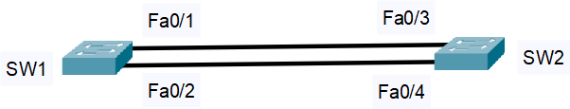

Figure 2-2a: An EtherChannel Network

SW1#show running-configuration  Building configuration…  …  interface Port-channel1 Switchport mode trunk  !  interface FastEthernet0/1 Switchport mode trunk Duplex full  Channel-group 1 mode passive  !  interface FastEthernet0/2 Switchport mode trunk Duplex full  Channel-group 1 mode passive | SW2#show running-configuration  Building configuration…  …  interface Port-channel1 Switchport mode access  !  interface FastEthernet0/3 Switchport mode access Duplex half  Channel-group 1 mode passive  !  interface FastEthernet0/4 Switchport mode access Duplex half  Channel-group 1 mode passive
Figure 2-2b: Partial EtherChannel configurations for SW1 and SW2

  - Identify the type of EtherChannel that is being used. (1 mark)

LACP passive

  - Identify errors in SW2 configurations. (3 marks)

- The switchport mode for interface FastEthernet0/3 and FastEthernet0/4 should be set as trunk mode instead of access mode.
- The duplex settings of interface FastEthernet0/3 and FastEthernet0/4 on SW2 (Half duplex) do not match with the interface FastEthernet0/1 and FastEthernet0/2 on SW1 (Full duplex).
- Since the SW1’s interfaces are using passive mode, the etherchannel group will not be formed if SW2’s interfaces are also applying passive mode.

  - Suggest the solutions and configurations to the answers you mentioned in Question 2 b)
(ii). (6 marks)

- The switchport mode on both interfaces FastEthernet0/3 and FastEthernet0/4 in SW2 should be set as trunk mode.
  - int range f0/3-4
  - switchport mode trunk
- The duplex on both interfaces FastEthernet0/3 and FastEthernet0/4 in SW2 should be set as full duplex.
  - int range f0/3-4
  - duplex full
- The port-channel 1 mode in SW2 should be switched to active mode.
  - int range f0/3-4
  - no channel-group
  - channel-group 1 mode active

